Bahria University,

Karachi Campus



LAB EXPERIMENT NO.

___03___

LIST OF TASKS

|  |  |
| --- | --- |
| TASK NO | OBJECTIVE |
| **01** | **Perform all the commands provided in the lab manual** |
| **02** | **Create an empty file with a .txt extension. Write a shell script that would write the current date, student’s name and registration number into that file, while using variables for all three entries.** |
| **03** | **Create a .txt file and input ten lines of entry while mixing it with both alphanumeric characters. Sort the contents of the created file in an ascending order and write the sorted output into another file.** |
| 04 | write a Program to Sum of Natural Numbers Using for Loop |

Submitted On:

23-03-2023

(Date: DD/MM/YY)

**Task 01:** Perform all the commands provided in the lab manual

**Output:**

* **Find:**



* **Grep:**



* **Sort:**

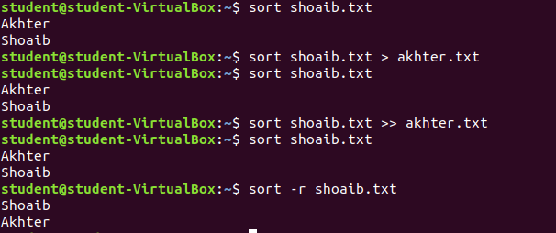

**Task 02:** Create an empty file with a .txt extension. Write a shell script that would write the current date, student’s name and registration number into that file, while using variables for all three entries.

**Solution:**

#!/bin/bash

echo "Enter your beautiful name"

read varName

echo "Enter current data"

read varDate

echo "Enter Registration Number"

read varReg

echo

echo "My name is $varName"

echo "The current date is $varDate"

echo "The Registration Number is $varReg"

**Output:**

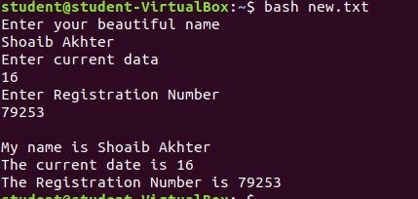

**Task 03:** Create a .txt file and input ten lines of entry while mixing it with both alphanumeric characters. Sort the contents of the created file in an ascending order and write the sorted output into another file.

**Output:**

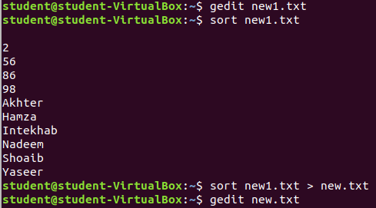

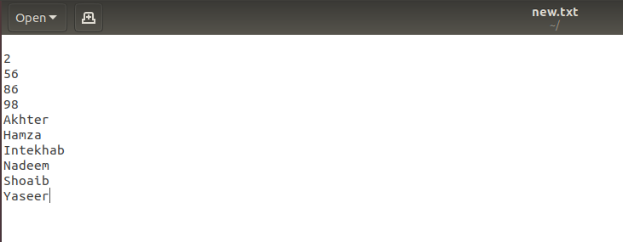

**Task 04:** Write a Program to Sum of Natural Numbers Using for Loop

**Solution:**

#include<stdio.h>

int main(){

int lastNum,add=0;

printf("Enter Last Natural Number for addition ");

scanf("%d",&lastNum);

for(int i=1;i<=lastNum;i++){

add=add+i;

}

printf("The sum from 1 to %d is %d \n",lastNum,add);

return add;

}

**Output:**

